Adv Mapreduce Assignment

Task-1 **Find the number of unique listeners in the data set.**

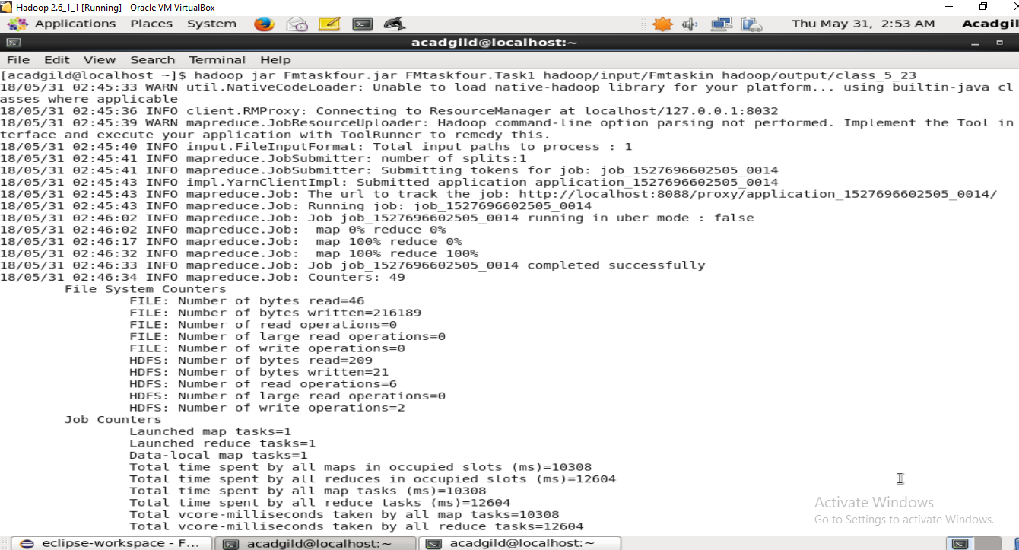

Output

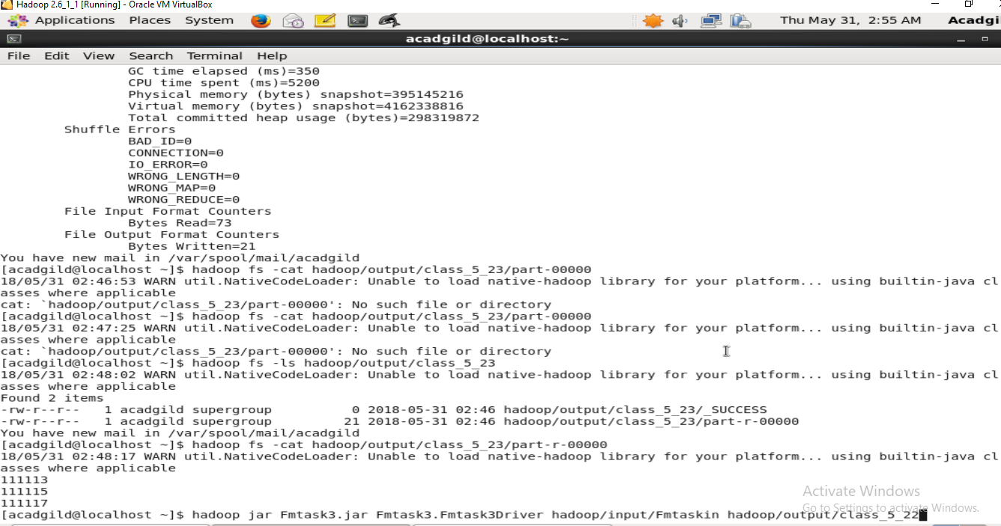

Assignment -2 **What are the number of times a song was heard fully.**

Jar execution

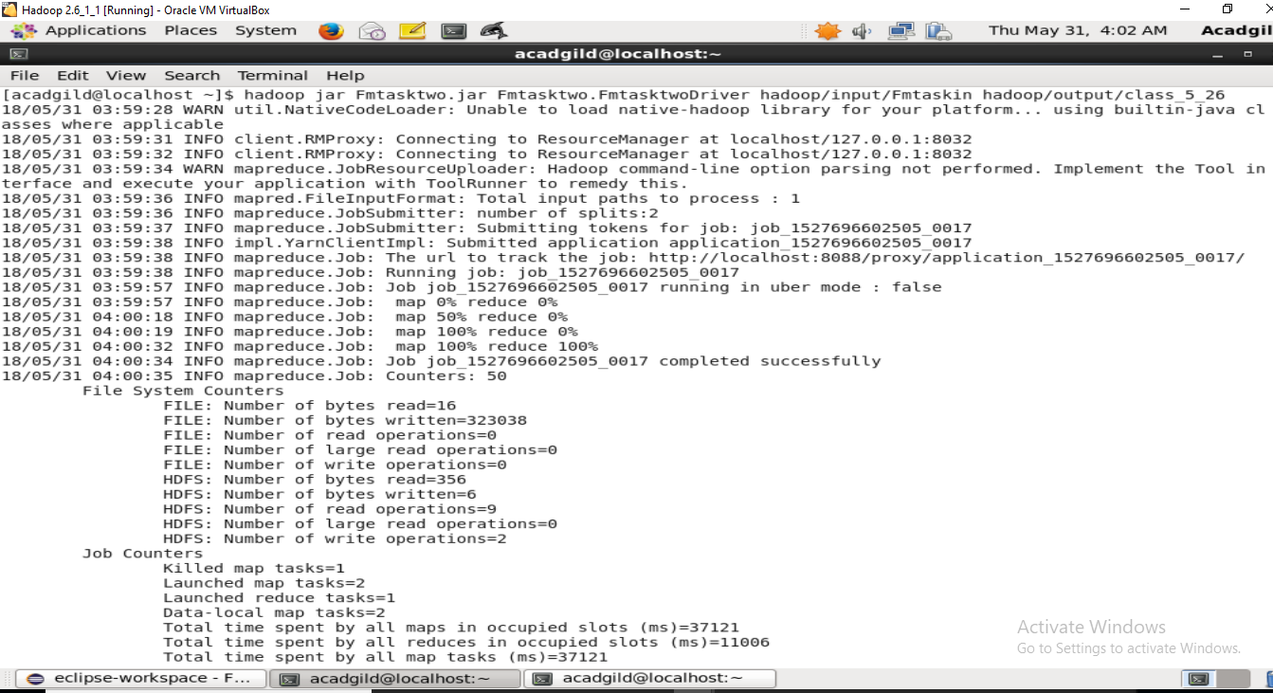

Output

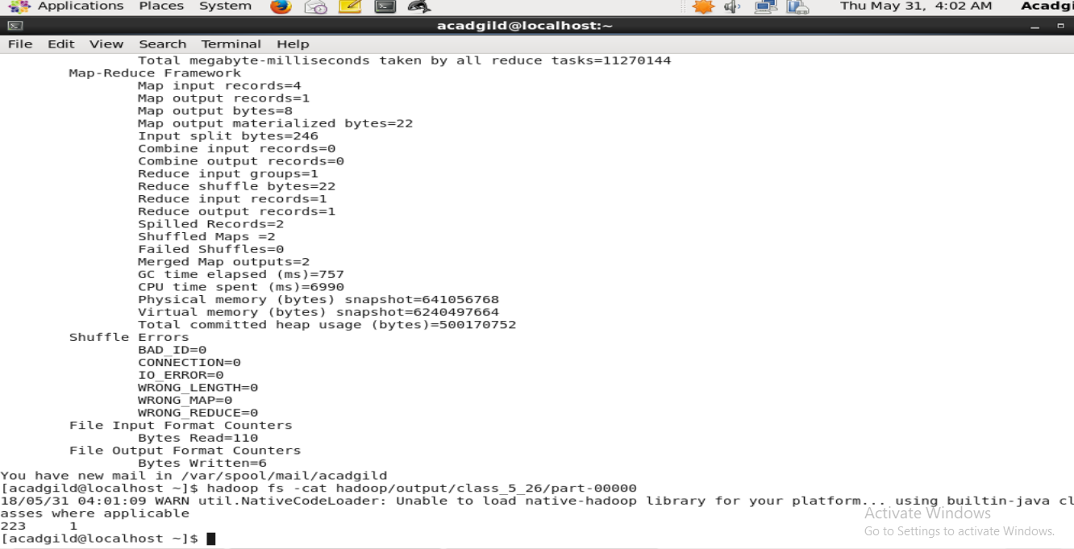

Assignment -3 **What are the number of times a song was shared.**

Jar execution

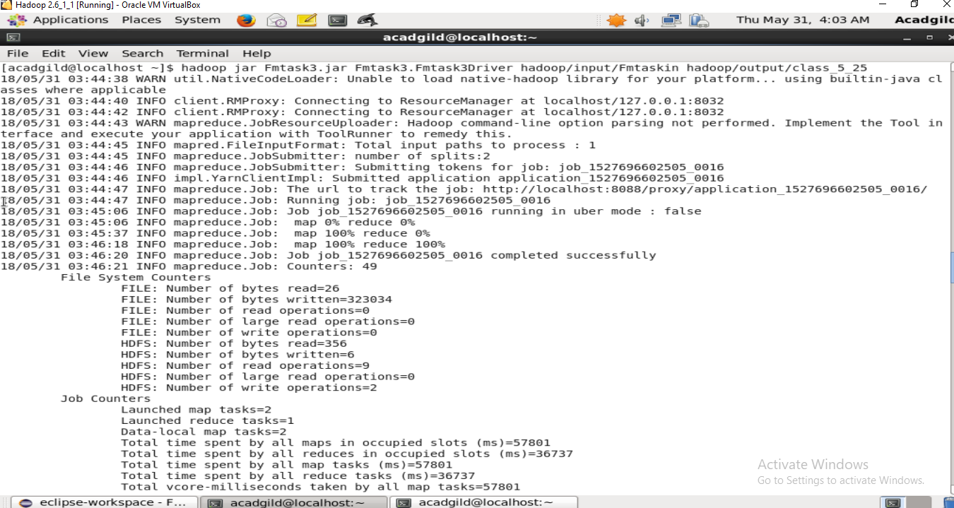

Output

